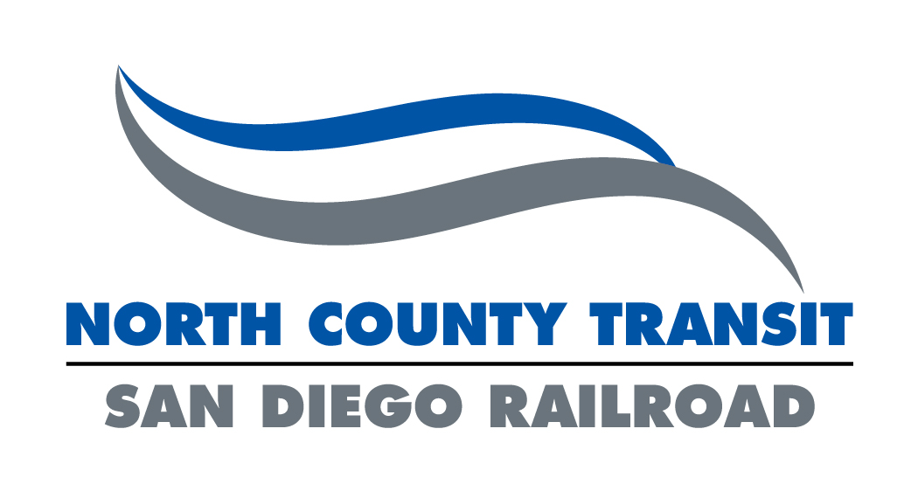 |  |  |  |  | Request for Right-of-Way Support Services
 |  |  |  |  | Service Requested:
 |  |  |  |  | NCTD Permit #:
* Billing Entity & Contact Information:
Right-of-Way Support Request  - Select Service(s) |  | Request By: |  |  |  | Project:
Signal Support |  | Requestor Email: |  |  |  | Field Contact Email:
Track Inspection |  | Requestor Cell Number: |  |  |  | Field Contact  Cell Number:
Signal Mark-Out |  | Organization: |  |  |  | Meeting Location:
Support Service(s) Time(s) & Date(s) |  | Hours (24 Hr. Format): |  |  |  | Date(s)  (Begin/End):
Proposed Work  (Signal Support/Track Inspection) |  | Describe work to be performed, equipment and tools to be used and system(s) that may be affected:
Location of Work  (Signal Support/Track Inspection) |  | Provide exact location of work with begin/end limits using railroad mileposts:
Signal Mark-Out |  | (Signal mark-out requests must also complete the sections below, providing as much detail as possible)
Proposed Work |  | Describe work to be performed (excavation, boring, grading), equipment to be used, depth of excavation/bore/grading and material to be installed:
Location of Work |  | Provide exact location of work and begin/end limits of locating and mark-out being requested. Provide location of work using Railroad Milepost (to one hundredth of a mile) and offset from known structure or roadway.
Attachments  (All Requests) |  | Attach relevant plan sheets, excavation/boring/grading plan, exhibits or sketches and/or aerial images:
APPROVAL |  | Originator: | Signature: _______________________________________ |  |  |  |  |  | Date: | _____________
 |  | Originator: | Title: ___________________________________________ |  |  |  |  |  | Date: | _____________
 |  | NCTD: | Signature: ______________________________________ |  |  |  |  |  | Date: | _____________
 |  | NCTD: | Title: ___________________________________________ |  |  |  |  |  | Date: | _____________

